Introduction

The Cobra series is a SCARA robotic mechanical system from Adept Technology Inc. It has 4 joints of articulation of which the third is a prismatic (translational) joint and the remaining three are revolute. The axes of all joints at any point are always parallel. As a result of this setup, the robot is more compliant in the x-y direction and less so in the z direction, i.e. the robot is selectively compliant.

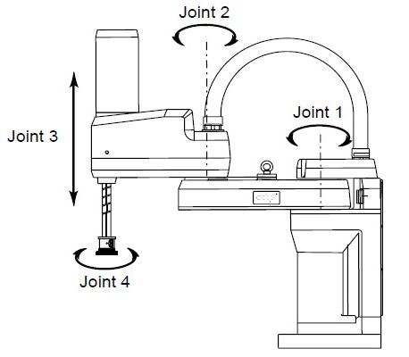

The first three joints are used for positioning, while the orientation of the end-effector is handled entirely by the fourth joint.

This project will be dealing with the i600 version of the Cobra series. It has been named so because it has a reach of 600mm.

Specifications:

The Technical Data for the i600 as provided by Adept Technologies is as follows:

Adept Cycle – Burst Pass-through User Connections
2 kg – 0.42 sec Electrical: 24 (12 twisted pairs)
Pneumatic: 6mm (x2), 4mm (x3)
Adept Cycle – Sustained DeviceNet: 1
2 kg – 0.45 sec
Payload
Digital I/O Channels Rated: 2.0 kg (4.4 lbs)
AIB: 12 inputs, 8 inputs Maximum: 5.5 kg (12.1 lbs)
Optional solenoid: 4 inputs
Power Requirements
Downward Push Force (No Load) 24 VDC: 6A
35 kgf – maximum 200 – 240 VAC: 10 A, signle-phase

Footprint Reach
338mm x 200mm 600mm (23.6”)

Joint Ranges Repeatability
Joint 1: XY:
Joint 2: Z:
Joint 3: 210mm Theta:
Joint 4:
Robot Brakes
Joint Speeds – Maximum Joints 1, 2 and 4: Dynamic
Joint 1: 386º/sec Joint 3: Electric
Joint 2: 720º/sec
Joint 3: 1100mm/sec Weight (without options)
Joint 4: 1200º/sec 41 kg (90 lbs)

Moment of Inertia Environmental Requirements
Joint 4 – 450 kg-cm² (150 lb-in²) – max Ambient Temperature: 5 – 40 ºC
Humidity Range: 5 – 90 %
(non-condensing)

Dimensions:

The dimensions of the robotic assembly as provided by Adept Technologies is as follows:

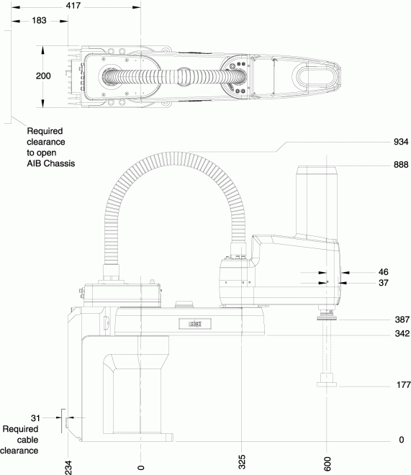

Workspace:

The top figure shows a top view workspace envelope for the i600. The figure below shows a 3D workspace envelope for the same. Our knowledge of the workspace is paramount to ensure we can control and position the end-effector properly.

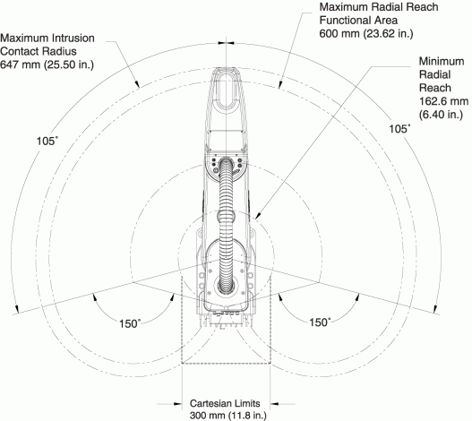
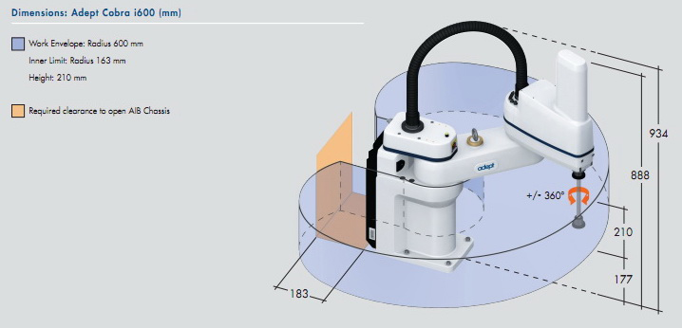

Forward Kinematics:

To calculate the forward kinematics we shall first assign the axes for each joint as shown in the figure. Next we tabulate the MDH table as follows.

Current Frame | Next Frame | Joint Number | Joint Type | Joint Variable | a |  | d
0 | 1 | 1 | R |  | 0 | 0 | 387
1 | 2 | 2 | R |  | 325 | 0 | 0
2 | 3 | 3 | P | d | 275 | 180 | d3 | 0
3 | 4 | 4 | R |  | 0 | 0 | 0

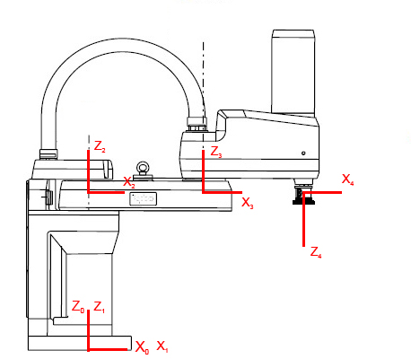

Axes declaration
Now that we have the MDH table set up we can begin to find the individual transformation matrix from one joint to the next using the formula:

…............................. (1)

Using the equation (1) we get,

…..... (2)

To get the final transformation function of the end effector with respect to the base,

…............................. (3)

From equations (2) and (3) we get,

Inverse Kinematics:

From equation (3),
…....................... (4)

Now, in this case we know the actual value of . For the sake of this derivation, we shall assume it to be ,

…......................... (5)

From equations (2)
…... (6)

Also, we can find,
….............................. (7)

From equations (4), (5), (6) and (7)

….............................. (8)

Again from equations (4), (5), (6) and (7)

…................................(9)

Squaring the above two equations and adding we get,

Now from the relation,

Now we shall use the ArcTan2 function to get . This will ensure that we attain a in the correct quadrant.

Note:

…........................... (10)

It should be noted that depending upon whether the value of is positive or negative we can get two possible answers for .

If we revisit equations (9)

Now both and are known values. Solving these equations simultaneously for and we get,

From this we get,

It should be noted that depending upon the value of , we can get two distinct values of .

Again from equations (4), (5), (6) and (7),

Therefore,
…...................... (11)

It should be noted that since there are two possible combinations of and , therefore you will get two possible solutions for .

In total for any given point in the workspace of the Cobra, there can be a maximum of two distinct possible ways to reach it. Just from inspection it is obvious that these possibilities exist due to the construction of the robot to be able to take either 'lefty' or 'righty' positions. In other words 'elbow in' or 'elbow out'. The only position in the workspace for which only one possibility exists is at the border of the workspace. At the farthest possible reach of the robot, the robot arm is completely stretched out so there is no question of 'elbow in' or 'elbow out'. Also, for a majority of the remaining edge, although the arm is not completely stretched out, but there is only one possible configuration to reach it due to the inherent angle limitations.

Using a mathemical tools such as MATLAB, Scilab, Mathematica etc. we can solve the forward and inverse kinematics fairly quickly. The following is the forward and inverse kinematics of the Cobra i600 done in Mathematica.

Note: The ArcTan2 function is written as a simple ArcTan function in mathematica. Depending upon whether you pass 1 or two arguments it will solve accordingly.

Palletizing:

For our palletizing programs, we will need to establish a coordinate frame. We will do this by using the command,

SET frame.name = FRAME(loc1, loc2, loc3, loc4)

The FRAME command returns a coordinate frame with loc4 as the origin, x-axis from loc1 to loc2 and y-axis from x-axis to loc 3 and using the SET command we can assign the frame a name. It is important to note that the robot uses a right handed cartesian coordinate system with the z-axis pointing vertically downward, i.e. towards the base.

Other commands used in the program are,

MOVE(S) loc

This is a simple move command which makes the robot move the end-effector to the specified location. If MOVES is used then the movement to the desired location is done in a straight line path.

APPRO(S) loc, height

This command makes the robot move the end-effector over the desired location ('loc') at a certain height'. If APPROS is used the movement is in a straight line path.

DEPART(S) height

This command make the robot move away from the current point vertically. In this case whether DEPART is used or DEPARTS is used the movement is always in a straight line because this is a SCARA robot.

OPENI, CLOSEI,

These commands respectively open and close the gripper at the end-effector.

TRANS (x, y, z, n, p, r)

This command returns a transformation as defined by the six cartesian components. This proves to be especially useful as it allows us to put the 'placing operation' within a loop in spite of different locations at which the blocks will be placed. The loop can be used to constantly calculate the placing position of the block in hand and using the TRANS function we can attain the new position for the robot to travel to.

BREAK

This command makes the robot pause and delay execution of the program until current operation finishes.

LEFTY, RIGHTY

These aren't commands exactly, but a state of configuration. If it precedes a MOVE or APPRO command it attains a lefty (elbow out to the left) or a righty (elbow in to the right) configuration. It is important to leverage this particular command if we are to exploit the entire workspace of the robot. If we are working to the right of the robot, we should attain a 'lefty' configuration and similarly if we are working to the left of the robot we should attain a 'righty' configuration. It is important to note that if these statements is followed by a MOVES or an APPROS command, the straight line motion feature of these commands will override the switch from lefty to righty or vice versa.

IF, FOR

These are conditional execution and iteration commands respectively which is common in a multitude of computer softwares.

WAIT NOT signal

We use this command to make the robot wait for the block to arrive at a certain spot on the conveyor belt. Once the block trips infrared sensor the value of 'signal' becomes 0 and the robot can stop waiting.

HERE location_name

To set the frame, have the robot move autonomously to the pick up point and move smoothly over to the palette we will need to define certain points in space. We do this by using the HERE command in the monitor window. Once the point has been named the robot can be made to go to that point repeatedly using a simple MOVE command.

The following are programs for square/rectangular and circular palettizing written in the V+ programming module which is a part of the Adept ACE software package which comes with this particular Adept product.

Square/Rectangular palette:

First and foremost, we need to figure out the minimum clearance distance required to ensure that while placing the blocks on the palette the blocks don't hit each other or that the gripper itself doesn't hit one of the blocks on the palette while lowering or when opening.

If the gripper opens in the y-direction, as is the case in the program, the minimum clearance distance happens to be half of the maximum distance that can be attained between the gripper's 'fingers'. Our gripper can open up to about 90mm. To ensure, that nothing gets hit we set the clearance in the y-direction a static 50 mm.

However, the x-direction clearance is a little more complicated. For this the length of the block being placed in the x-direction is needed. Assuming that all blocks are of the same exact length then the minimum distance between any two blocks in the x-direction is equal to the length of the block along the x-direction. To ensure, that nothing gets hit we add another 5mm to the clearance.

If the cell spacing provided by the user is lesser than these calculated clearances then the robot shouldn't move.

It is important to note that the provided cell spacing is what decides whether the palette is going to be a square one or a rectangular one. If the cell spacing in the x and y directions are equal then it results in a square palette and if they are different it results in a rectangular palette.

Program:

.PROGRAM adil_saad()
;
; ABSTRACT: To set up a square/rectangular palette.
;
; INPUTS:
;
; OUTPUTS:
;
; SIDE EFFECTS:
;
; DATA STRUCT:
;
; MISC: Program created in ACE version 3.0.2.11
;
;* Copyright (c) 2011 by {Adil_Saad}

appro.pick = 80 ;
depart.pick = 80 ;
appro.place = 140 ;
depart.place = 140 ;

rob.speed = 20 ;
mon.speed = 25 ;

c.spx = 75 ;

c.spy = 75 ;

; Dimensions of the block ;
block_length = 45 ;
block_width = 35 ;

clearance.y = 50 ;
clearance.x = block_length+5 ;

SET a.s.frame = FRAME(pallete.origin,pallete.pt2,pallete.pt1,pallete.origin) ;

SPEED rob.speed ALWAYS ;

;Check for clearance;
IF c.spy < clearance.y THEN
TYPE "Not enough clearance. Gripper hits adjascent blocks in y direction" ;
KILL ;
END

IF c.spx < clearance.x THEN
TYPE "Not enough clearance. Block does not clear adjascent blocks in x direction"
KILL ;
END

LEFTY ;
MOVE a.s.via ;
MOVE idle ;
BREAK ;

WAIT NOT (SIG(1002)) ;

FOR i = 0 TO 15

FOR j = 0 TO 1

; Picking up the piece;
APPROS a.s.pick, appro.pick ;
MOVE a.s.pick ;
BREAK ;

CLOSEI ;
DEPART depart.pick ;
BREAK ;

; Move via 'idle' to 'a.s.via';
MOVES idle ;
RIGHTY ;
MOVE a.s.via ;
BREAK ;

; Go to point of interest and place;
APPROS a.s.frame:TRANS(c.spx*i,c.spy*j,0,0,0,-45), appro.place ;
BREAK ;
MOVE a.s.frame:TRANS(c.spx*i,c.spy*j,0,0,0,-45) ;
BREAK ;
OPENI ;

; Depart to 'idle';
DEPART depart.place ;

MOVES a.s.via ;
LEFTY ;

MOVE idle ;
BREAK ;
WAIT NOT (SIG(1002)) ;
END
END

.END

The following flowchart explains the logic behind the program. Note that 'n' in the flowchart is one more than the number of 'rectangles' created. Therefore to make a proper square/rectangle a minimum of four blocks is needed and 'n' is two.

Circular Palette:

Again, calculation of the minimum required clearance is paramount. However the calculation of the clearance of a circular palette is much more complicated. Since it is a circular palette the clearance to be calculated in terms of radius and the angle between the blocks. The calculation of this is slightly complicated as the blocks are rectangular cuboids.

The first clearance to be calculated is the minimum angle between two positions for any given radius. If the angle provided by the user to place the blocks is less than this, then the user has to either increase the angle or increase the radius. This turns out to be,

The second clearance to be calculated is to make sure that gripper does not hit an adjacent block. We know that the gripper opens up to a max distance of roughly 90mm. To ensure nothing gets hit assume that half the open gripper distance is 50mm. Using, this we can find the minimum width of the block for a given set of angleand radius r. This turns out to be,

Program:

.PROGRAM adilsaad_circle()
;
; ABSTRACT: To set up a circular palette
;
; INPUTS:
;
; OUTPUTS:
;
; SIDE EFFECTS:
;
; DATA STRUCT:
;
; MISC: Program created in ACE version 3.0.2.11
;
;* Copyright (c) 2011 by {Adil-Saad}

appro.pick = 80 ;
depart.pick = 80 ;
appro.place = 140 ;
depart.place = 140 ;

rob.speed = 5 ;
mon.speed = 25 ;

csp.rad = 30 ;
csp.th = 5 ;

; Dimensions of the block ;
b_l = 45 ;
b_w = 35 ;

dummy1 = b_w/2 ;
dummy2 = csp.rad-(b_l/2) ;
dummy3 = ATAN2(dummy1,dummy2) ;
dummy4 = 2*dummy3 ;
check = dummy4+10 ;

IF check < csp.th THEN
TYPE "Blocks will hit each other"
KILL ;

END

x.off = 50 ;
y.off = 150 ;

SET a.s.frame = FRAME(pallete.origin,pallete.pt2,pallete.pt1,pallete.origin) ;

SPEED rob.speed ALWAYS ;

LEFTY ;

MOVE a.s.via ;

MOVE idle ;
BREAK ;

FOR i = 0 TO 3

; Picking up the piece;
APPROS a.s.pick, appro.pick ;
MOVE a.s.pick ;
BREAK ;

CLOSEI ;
DEPART depart.pick ;
BREAK ;

; Move via 'idle' to 'a.s.via';
MOVES idle ;
RIGHTY ;
MOVE a.s.via ;
BREAK ;

;Move to point of interest;
APPRO a.s.frame:TRANS(x.off+csp.rad*COS(csp.th*i),y.off+csp.rad*SIN(csp.th*i),0,0,0,- 45+csp.th*i), appro.pick ;

BREAK ;
MOVE a.s.frame:TRANS(x.off+csp.rad*COS(csp.th*i),y.off+csp.rad*SIN(csp.th*i),0,0,0,- 45+csp.th*i) ;
BREAK ;
OPENI ;

; Depart to 'idle';
DEPART depart.place ;

MOVES a.s.via ;
LEFTY ;

MOVE idle ;
BREAK ;
WAIT NOT (SIG(1002)) ;

END

WAIT NOT (SIG(1002)) ;

.END

The following is a flowchart explaining the logic behind the program. It is important to note that 'n' is the number of blocks to be placed.

Steps to Download commands to the controller:

- Plug in the power cable for the robot and the computer used to program and control the robot.
- Switch the computer on.
- Switch the power button for the robot on.
- Switch the air pressure valve, that controls the gripper for the robot, on.
- Switch the conveyor belt on.
- Start the Adept Ace software.
- Write the program in the V+ module of the program.
- Save the program.
- Use the monitor window to teach the robot the various points in space required for the running of the operation.
- Turn off the E-stop.
- Click the power button in the software and hold down the hi-power button to provide power to the robot.
- Click the Controller Development tools icon. This will open up a new window showing a list of tasks that the robot will perform.
- Drag the program onto the first task.
- Click the play icon.

Conclusion:

We looked into the specs, dimensions and workspace of the Cobra i600. We derived the forward and inverse kinematic equations and wrote a program in Mathematica to be able to do so switftly. We wrote a program in Adept's proprietary program Adept ACE using the V+ module to create a rectangular and circular palette. We delineated the steps involved in downloading the program to the controller.

References:

Images and robot specifications, courtesy of Adept Technologies Inc.
www.adept.com

Name: Saad Saeed
UTD: 1000679534
Course: Introduction to Robotics

The Adept Cobra i600
